VASAVI COLLEGE OF ENGINEERING (AUTONOMOUS)
IBRAHIMBAGH, HYDERABAD-31
Department of Computer Science and Engineering

Name of the Course: Design & Analysis of Algorithms
Assignment – 3

Name of the Faculty: Dr.M.Sunitha Reddy Date of submission: /06/2023
Class: B.E 2/4 A Sem: IV

Set-1 (1602-21-733-012, 013, 015, 020, 026, 029, 032, 036, 037, 069)

Q.no | Question | Marks | BTL (1/2/3/4/5/6) | CO | PO
1 | You are helping the medical consulting firm Doctors Without weekends set up the work schedules of doctors in a large hospital. They’ve got the regular daily schedules mainly worked out. Now, however, they need to deal with all the special cases and, in particular, make sure that they have at least one doctor covering each vacation day.  Here’s how this works. There are k vacation periods (e.g., the week of Christmas, the July 4th weekend, the Thanksgiving weekend, . . . ), each spanning several contiguous days. Let Dj be the set of days included in the jth vacation period; we will refer to the union of all these days, ∪jDj, as the set of all vacation days. There are n doctors at the hospital, and doctor i has a set of vacation days Si when he or she is available to work. (This may include certain days from a given vacation period but not others; so, for example, a doctor may be able to work the Friday, Saturday, or Sunday of Thanksgiving weekend, but not 2 Applying 4 1,2,3the Thursday.)  Design a polynomial-time algorithm and C Program that takes this information and determines whether it is possible to select a single doctor to work on each vacation day, subject to the following constraints.  • For a given parameter c, each doctor should be assigned to work at most c vacation days total, and only days when he or she is available.  • For each vacation period j, each doctor should be assigned to work at most one of the days in the set Dj. (In other words, although a particular doctor may work on several vacation days over the course of a year, he or she should not be assigned to work two or more days of the Thanksgiving weekend, or two or more days of the July 4th weekend, etc.)  The algorithm should either return an assignment of doctors satisfying these constraints or report (correctly) that no such assignment exists | 2 | 3 | 4 | 1,2,3
2 | Given a path in the form of a rectangular matrix having few landmines arbitrarily placed (marked as 0), calculate length of the shortest safe route possible from any cell in the first column to any cell in the last column of the matrix. We have to avoid landmines and their four adjacent cells (left, right, above and below) as they are also unsafe. We are allowed to move to only adjacent cells which are not landmines. i.e. the route cannot contains any diagonal moves. Write a C program and analyze the time complexity. | 1 | 3 | 4 | 1,2,3
3 | NP-Completeness, In this problem, you will prove NP-completeness of a few decision problems. To prove NP-hardness, you may reduce from any problem that has been shown, in class or in CLRS, to be NP-complete.  (a) Let TRIPLE-SAT denote the following decision problem: given a Boolean formula φ, decide whether φ has at least three distinct satisfying assignments. Prove that TRIPLE-SAT is NP-complete.  (b) In Problem Set 1, we considered how one might locate donut shops at some of the vertices of a street network, modeled as an arbitrary undirected graph G = (V,E). Each vertex u has a nonnegative integer value p(u), which describes the potential profit obtainable from a shop located at u. Two shops cannot be located at adjacent vertices. The problem wasto design an algorithm that outputs a subset U ⊆ V that maximizes the total profit . No doubt, you found an algorithm with time complexity that was exponential in the graph parameters.  Define DONUT to be the following decision problem: given an undirected graph G = (V,E), given a mapping p from vertices u ∈ V to nonnegative integer profits p(u), and given a nonnegative integer k, decide whether thereis a subset U ⊆ V such that no two vertices in U are neighbors in G, and such that ≥ k. Prove that DONUT is NP-hard. (Hint: Try a reduction from 3SAT.) Also, explain why this implies that, if there is a polynomial-time algorithm to solve the original problem, i.e., to output a subset U that maximizes the total profit, then P = NP.  (c) Suppose we have one machine and a set of n tasks a1, a2, . . . , an. Each task aj requires tj units of time on the machine, yields a profit of pj , and has a deadline dj . Here, the tj , pj , and dj values are nonnegative integers. The machine can process only one task at a time. Not all tasks have to be run, but if a task starts running, it must run without interruption and must complete by its deadline.  A schedule for a subset of the tasks describes when each of the tasks in the subset starts running. A schedule must observe the constraints given above. The profit for the schedule is the sum of all the pj values for the tasks aj in the schedule.  The problem is to produce a schedule for a subset of the tasks that returns the greatest possible amount of profit. State this problem as a decision problem and show that it is NP-complete. In showing this, you may reduce from any problem that has been shown, in class or in CLRS, to be NP-complete. | 1 | 3 | 5 | 1,2,3
4 | A Clique is defined as, Given a graph G(V, E) and a positive integer k, return 1 if and only if there exists a set of vertices S ⊆ V such that |S| ≥ k and for all u, v ∈ S (u, v) ∈ E. Prove Largest Clique is an NP-Complete Problem | 1 | 3 | 5 | 1,2,3

Set-2 (1602-21-733-001, 002,003,004,005,006,007,008)
Q.no | Question | Marks | BTL (1/2/3/4/5/6) | CO | PO
1 | 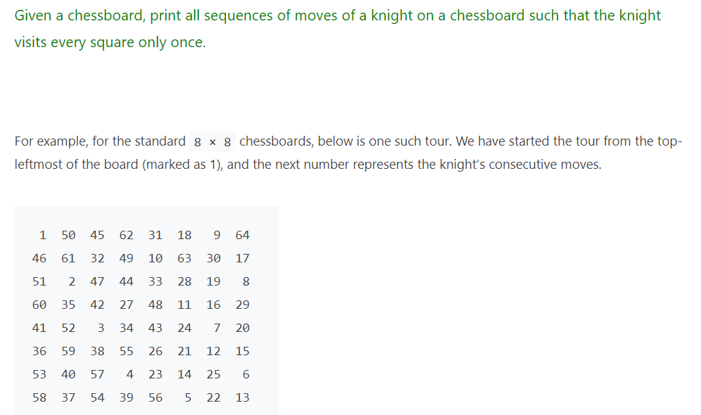 | 2 | 3 | 4 | 1,2,3
2 | Find the Chromatic number for the graph given below. Draw the state space tree to show all possible colorassignments.  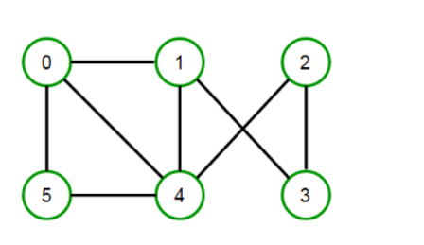 | 1 | 3 | 4 | 1,2,3
3 | A Travelling Salesman Problem (TSP) is defines as, Given a set of cities and distance between every pair of cities, the problem is to find the shortest possible route that visits every city exactly once and returns back to the starting point. Is the TSP problem NP-Complete? Justify your answer with relevant reasons and proof. | 1 | 3 | 5 | 1,2,3
4 | Show that the problem of determining the satisfiability of Boolean formulas in disjunctive normal form is polynomial-time solvable. | 1 | 3 | 5 | 1,2,3

Set-3 (1602-21-733-009, 010,011,014,016,017,018,019)

Q.no | Question | Marks | BTL (1/2/3/4/5/6) | CO | PO
1 | Given a Maze in the form of a binary rectangular matrix, Write an algorithm to find the shortest path length in the maze from a given source to a destination. The path can only be constructed out of cells having value 1 and at any moment we can only move one step in one of the four directions.  The valid moves are:  Go Up: (x,y) -> (x-1,y)  Go Down: (x,y) -> (x+1,y)  Go Left: (x,y) -> (x,y-1)  Go Right: (x,y) -> (x,y+1)  For example consider the following binary matrix. If source = (0,0) and destination = (7,5), the shortest path from source to the destination has length 12.  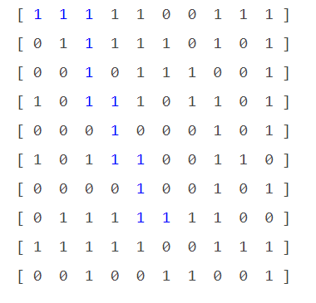 | 2 | 3 | 4 | 1,2,3
2 | Given the following 0-1 knapsack problem with  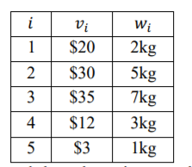  Draw the pruned state space tree and show the actions step by step using:  (a) Depth-first search.  (b) Breadth-first search.  (c) Best-first search | 1 | 3 | 4 | 1,2,3
3 | Prove that TSP is NP-complete | 1 | 3 | 5 | 1,2,3
4 | Show the steps to prove a problem as NP-Complete problem | 1 | 3 | 5 | 1,2,3

Set-4 (1602-21-733-020,021,022,023,024,025,027,028)
Q.no | Question | Marks | BTL (1/2/3/4/5/6) | CO | PO
1 | Consider the following problem. Given a positive number N, find all combinations of 2N elements with the following conditions:  • Every element from 1 to 2N appears exactly twice.  • The distance between the same element is exactly the value of the element.  For example: Input: N = 3  Output:  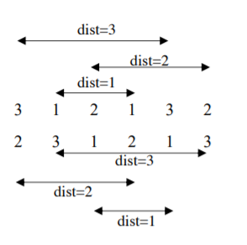  (a) Design the state space tree and describe your idea to solve this problem by backtracking.  (b) Implement this algorithm and analyze the time complexity | 2 | 3 | 4 | 1,2,3
2 | Subset sum problem is to find subset of elements that are selected from a given set whose sum adds up to a given number K. We are considering the set contains non-negative values. It is assumed that the input set is unique (no duplicates are presented). Use the Backtracking approach to solve it and 1 Applying 4 1,2,3implement a C program for the designed solution. Analyze the time complexity. | 1 | 3 | 4 | 1,2,3
3 | 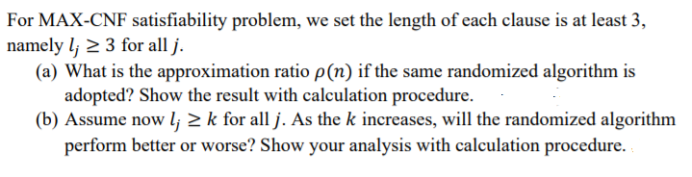 | 1 | 3 | 5 | 1,2,3
4 | Given a collection S of subsets of a set X, an exact cover is a sub collection S* of S such that each element in X is contained in exactly one subset in S*. Exact cover problem is a decision problem to determine if an exact cover exists. Prove Exact Cover problem is NP-Complete. | 1 | 3 | 5 | 1,2,3

Set-5 (1602-21-733-030,031,032,033,034,035,038,039)
Q.no | Question | Marks | BTL (1/2/3/4/5/6) | CO | PO
1 | A knight’s tour is a sequence of moves of a knight on a chessboard such that the knight visits every square only once. If the knight ends on a square that is one knight’s move from the beginning square (so that it could tour the board again immediately, following the same path), the tour is closed, otherwise it is open. Write a backtracking solution to solve Knight’s problem.  Example:  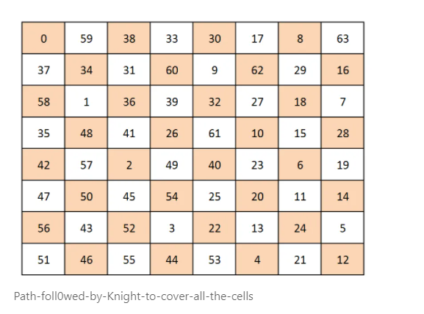 | 2 | 3 | 4 | 1,2,3
2 | Given a String, Write a C program to print all the permutations of it.  Input: A String  Output: Print all the permutations of a string  Example:  Input : abc  Output: abc acb bac bca cba cab | 1 | 3 | 4 | 1,2,3
3 | 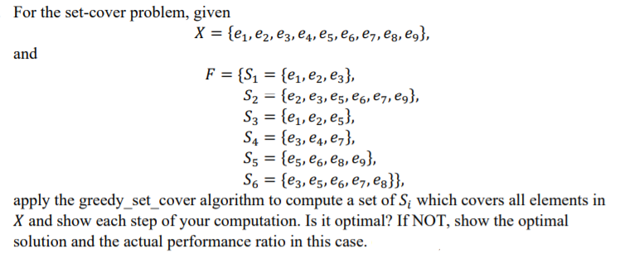 | 1 | 3 | 5 | 1,2,3
4 | Consider the feedback vertex set problem (FVS) in undirected graphs where you are given an undirected graph G, and the question is whether there exists a subset S of at most k vertices such that G \ S is a forest? i.e. S covers all cycles of the graph. Show that this problem is NP-complete. (Hint: reduce from Vertex Cover by converting edges into cycles, but be careful to prove rigorously.) | 1 | 3 | 5 | 1,2,3

Set-6 (1602-21-733-040 to 047)
Q.no | Question | Marks | BTL (1/2/3/4/5/6) | CO | PO
1 | Given an undirected graph and a number m, determine if the graph can be colored with at most m colors such that no two adjacent vertices of the graph are colored with same color. Here coloring of a graph means assignment of colors to all vertices. Design a C program to solve the using backtracking approach. Analyze the time complexity. Input: 1) A 2D array graph[V][V] where V is the number of vertices in graph and graph[V][V] is adjacency matrix representation of the graph. A value graph[i][j] is 1 if there is a direct edge from i to j, otherwise graph[i][j] is 0.  2) An integer m which is maximum number of colors that can be used. Output: An array color[V] that should have numbers from 1 to m. color[i] should represent the color assigned to the ith vertex. The code should also return false if the graph cannot be colored with m colors. | 2 | 3 | 4 | 1,2,3
2 | Given an M x N matrix, with a few hurdles arbitrarily placed, calculate the length of longest possible route possible from source to destination within the matrix. We are allowed to move to only adjacent cells which are not hurdles. The route cannot contain any diagonal moves and a location once visited in a particular path cannot be visited again. Write a C program and analyze the time complexity. For example, longest path with no hurdles from source to destination is highlighted for below matrix. The length of the path is 24 | 1 | 3 | 4 | 1,2,3
3 | Consider the following Hitting Set problem whose input consists of a pair (U, F) where U is a finite set of elements and F is a family of subsets of U. The question is whether there is a subset U 0 of U on at most k elements, such that U 0 ∩ F 6= ∅ for every F ∈ F. Such a set U 0 is called a hitting set.  (a) Show that the problem is in NP.  (b) Consider the following reduction from FVS of the previous problem. Given a graph G = (V, E), the universe U = V, the vertex set. And F contains subsets of vertices of all cycles in G. I.e. find a cycle C in G, and take the vertex set of C as a set in F. Show that G has a feedback vertex set of size at most k if and only if the reduced (U, F) has a hitting set of size at most k.  (c) Despite the claim in the previous subproblems, we haven’t proved the problem NP-complete, why?  (d) Give a reduction from Vertex Cover to prove the problem NP-complete. | 1 | 3 | 5 | 1,2,3
4 | In 0-1 Knapsack problem, items cannot be broken which means the item is taken as a whole or should leave it. Hence, in case of 0-1 Knapsack, the value of xi can be either 0 or 1. The weight wi and profit pi is associated with every item. The item is included only when the weight wi does not exceed the capacity of knapsack ‘m’. An optimal solution is obtained such that maximal profit is earned. Prove 0/1 Knapsack problem is an NP-Complete Problem. | 1 | 3 | 5 | 1,2,3

Set-7 (1602-21-733-048 to 055)
Q.no | Question | Marks | BTL (1/2/3/4/5/6) | CO | PO
1 | Design an algorithm to find all n–digit numbers with an equal sum of digits at even and odd index, where n varies from 1 to 9. Analyze the time complexity of the algorithm proposed. | 2 | 3 | 4 | 1,2,3
2 | A Maze is given as N*N binary matrix of blocks where source block is the upper left most block i.e., maze[0][0] and destination block is lower rightmost block i.e., maze[N-1][N_1]. A rat starts from source and has to reach destination. The rat can move only in two directions: forward and down.  In the maze matrix, 0 means the block is dead end and 1 means the block can be used in the path from source to destination. Note that this is a simple version of the typical Maze problem. For example, a more complex version can be that the rat can move in 4 directions and a more complex version can be with limited number of moves.  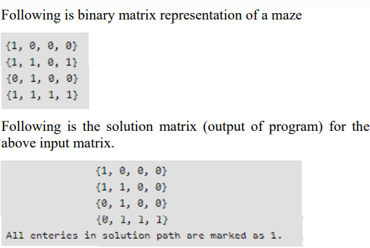  Write a C program for the designed solution and analyze the time complexity. | 1 | 3 | 4 | 1,2,3
3 | A Boolean Satisfiability is the problem of determining if a Boolean formula is satisfiable or unsatisfiable. If the Boolean variables can be assigned values such that the formula turns out to be TRUE, then we say that the formula is satisfiable. If it is not possible to assign such values, then we say that the formula is unsatisfiable. Prove Boolean Satisfiability problem is NP-Complete. | 1 | 3 | 5 | 1,2,3
4 | Design the Non deterministic procedure for a sorting algorithm. | 1 | 3 | 5 | 1,2,3

Set-8 (1602-21-733-056 to 062,064)

Q.no | Question | Marks | BTL (1/2/3/4/5/6) | CO | PO
1 | Given an array of positive integers arr[] and a sum x, find all unique combinations in arr[] where the sum is equal to x. The same repeated number may be chosen from arr[] unlimited number of times. Elements in a combination (a1, a2, …, ak) must be printed in non-descending order. (ie, a1 <= a2 <= … <= ak).  The combinations themselves must be sorted in ascending order, i.e., the combination with smallest first element should be printed first. If there is no combination possible the print "Empty" (without quotes)  Examples:  Input : arr[] = 2, 4, 6, 8  x = 8  Output :  [2, 2, 2, 2]  [2, 2, 4]  [2, 6]  [4, 4]  [8]  Use Backtracking approach to solve the problem. Write a C program for the designed solution and analyze the time complexity | 2 | 3 | 4 | 1,2,3
2 | Given a set of n integers, divide the set in two subsets of n/2 sizes each such that the difference of the sum of two subsets is as minimum as possible. If n is even, then sizes of two subsets must be strictly n/2 and if n is odd, then size of one subset must be (n-1)/2 and size of other subset must be (n+1)/2.  Write a C program and analyze the time complexity. For example, let given set be {3, 4, 5, -3, 100, 1, 89, 54, 23, 20}, the size of set is 10. Output for this set should be {4, 100, 1, 23, 20} and {3, 5, -3, 89, 54}. Both output subsets are of size 5 and sum of elements in both subsets is same (148 and 148).  Let us consider another example where n is odd. Let given set be {23, 45, -34, 12, 0, 98, -99, 4, 189, -1, 4}. The output subsets should be {45, -34, 12, 98, -1} and {23, 0, -99, 4, 189, 4}. The sums of elements in two subsets are 120 and 121 respectively | 1 | 3 | 4 | 1,2,3
3 | A Hamiltonian path is a path in an undirected or directed graph that visits each vertex exactly once. A Hamiltonian cycle (or Hamiltonian circuit) is a Hamiltonian path that is a cycle. Determining whether such paths and cycles exist in graphs is the Hamiltonian path problem. Prove that Hamiltonian Path is NP-Complete | 1 | 3 | 5 | 1,2,3
4 | The Subset Sum problem is as follows, given n non-negative integers w1, . . . , wn and a target sum W, the question is to decide if there is a subset I ⊂ {1, . . . , n} such that the sum of all the integers in the subset is equal to W. Prove Subset Sum is an NP-Complete Problem | 1 | 3 | 5 | 1,2,3

Set-9 (1602-21-733-065,066,067,135,136 ,301)
Q.no | Question | Marks | BTL (1/2/3/4/5/6) | CO | PO
1 | Analyze mColoring using the data as the complete graphs of size n=2,3,4,5,6 and 7. Let the desired number of colors be k=n and k=n/2. Tabulate the computing times for each value | 2 | 3 | 4 | 1,2,3
2 | Find the solution for the following 0/1 Knapsack problem with FIFO Branch and Bound (w1,w2,w3,w4)= (10,15,6,9), (p1,p2,p3,p4)= (2,5,8,1) m= 28 n=4 | 1 | 3 | 4 | 1,2,3
3 | Prove that Node covering problem is of NP-complete class | 1 | 3 | 5 | 1,2,3
4 | Give a formal encoding of directed graphs as binary strings using an adjacency-matrix representation. Do the same using an adjacency-list representation. Argue that the two representations are polynomially related | 1 | 3 | 5 | 1,2,3

Set-10 (1602-21-733-302 to 307)

Q.no | Question | Marks | BTL (1/2/3/4/5/6) | CO | PO
1 | Draw the portion of the state space tree generated by LCBB for the job sequencing instance with n=5, (p1..p5) = (6,3,4,8,5) (d1…d5) = (3,1,4,2,4) | 2 | 3 | 4 | 1,2,3
2 | Draw a portion of the state space tree generated by Hamiltonian algorithm for the following graph  A  C  B  E  D | 1 | 3 | 4 | 1,2,3
3 | Prove that the class NP of languages is closed under union, intersection, concatenation and Kleene closure | 1 | 3 | 5 | 1,2,3
4 | Show that circuit –satisfiability is NP-complete | 1 | 3 | 5 | 1,2,3

